CHAPTER: 7
FLOW DIAGRAM:
To show the work flow of our project GLOVOSIGN
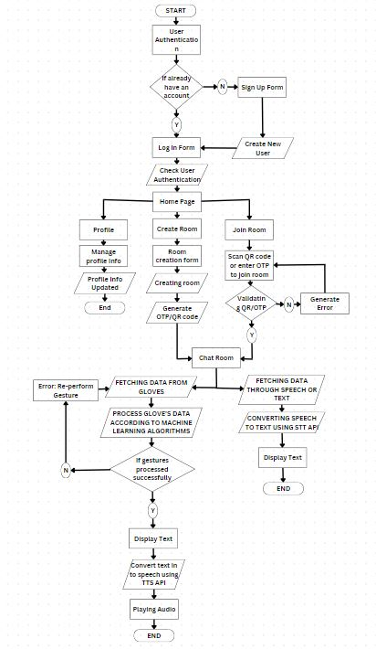
FIGURE 1: Data Flow
ER Diagram:
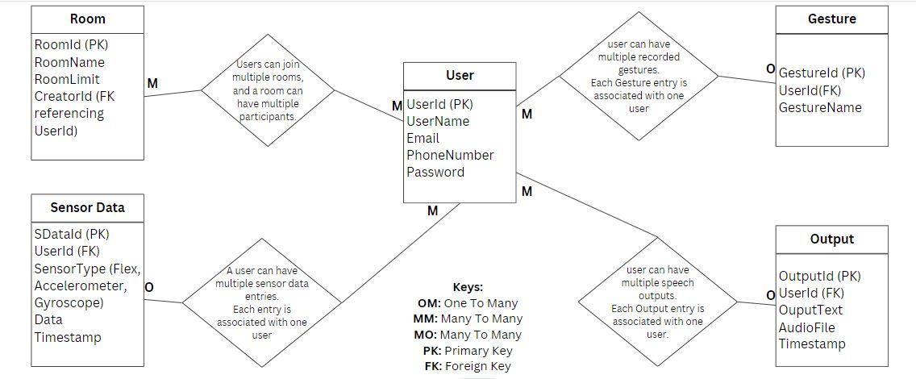
Fig no 1: ER Diagram

State Diagram:
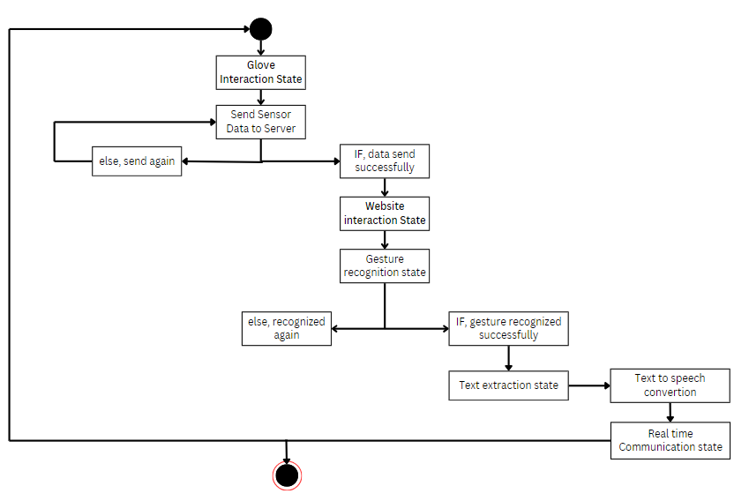
Fig no 2: State Diagram

Actor Diagram:
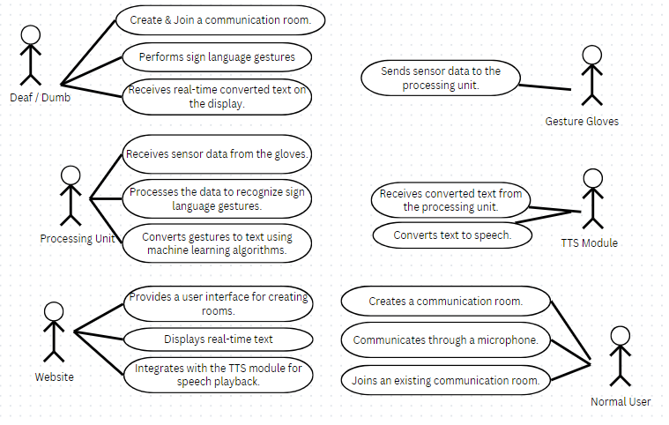
Fig no 3: Actor Diagram

Sequence Diagram:
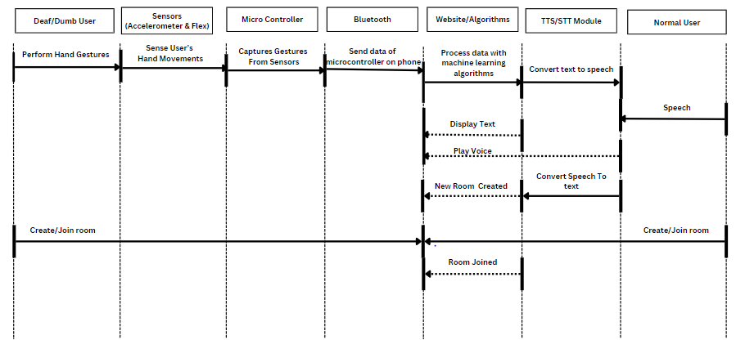
Fig no 5: Sequence Diagram

Data flow Diagram:
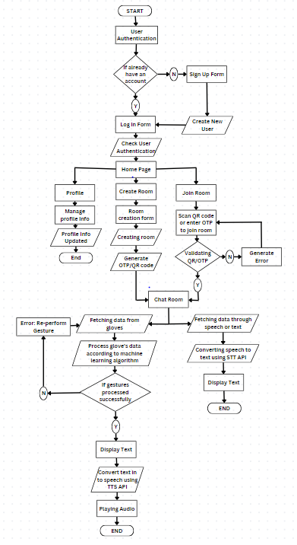
Fig no 6: Data Flow Diagram

